LOADING THE DATASET

Before building a view and analyzing the data, we must first connect the data to IBM Cognos. Cognos supports connecting to a wide variety of data, stored in a variety of places.

The data might be stored on your computer in a spreadsheet or a text file, or in a big data, relational, or cube (multidimensional) database on a server in the enterprise.  
In this case, we will be using a spreadsheet or text file for making our analysis.

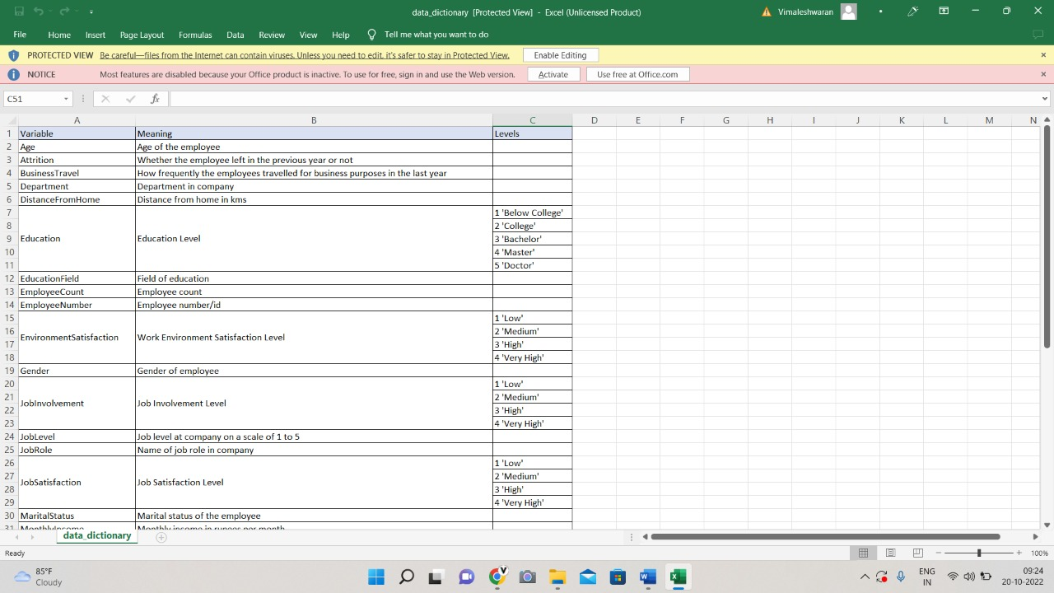

Upload data

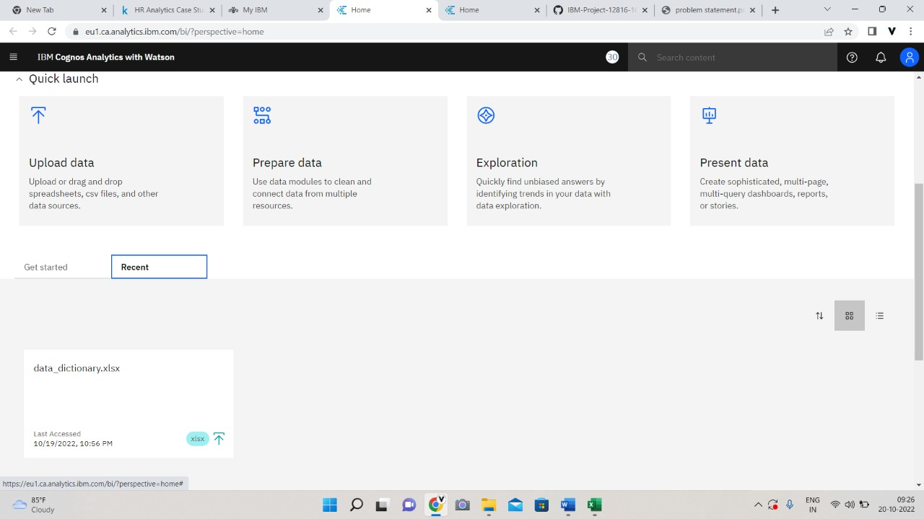

Prepare dataset

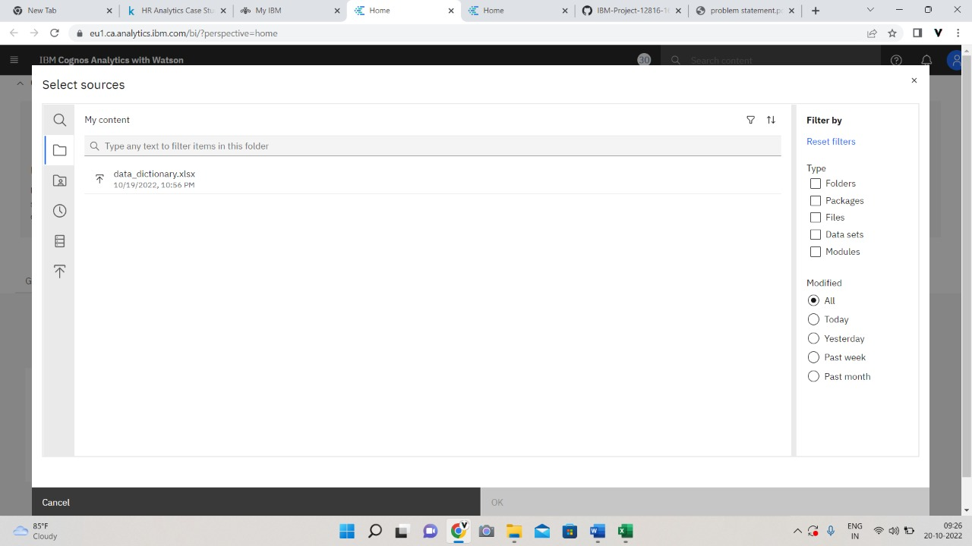

Select the dataset

